**The Home Depot E-commerce Delivery Network Optimization Models**

**Definition:**

*Delivery Agent (DA):* A third party carrier facility which serves as a local distributor for Home Depot customer orders. There are more than 500 DAs in the U.S.

*DC:* Home Depot Distribution Center. A Home Depot DC ships customer orders through line haul to local DAs. There are 3 Home Depot DAs in the U.S.

*Zip Codes:* There are approximately 40,000 customer zip codes in Home Depot database.

**Transportation Process:**

Home Depot DC 🡪 Delivery Agent 🡪 Customer zip codes

**1st Model - Last Mile Delivery Optimization:**

$$Min \sum_{i,j}{\left(C_{ij}+0.001*d_{ij}\right)*y_{ij}}$$

$$i:DA$$

$$j: customer zip code$$

$$C_{j}:cost of going from DA i to customer zip code j$$

$$d_{ij}:decisiion variable of assigning DA i to customer zip code j$$

$$y_{ij}=\left\{\begin{aligned}1, &if DA i is assigned to zip code j \\ 0, &Otherwise\end{aligned}\right.$$

$$\sum_{i}{y_{ij}=1 for ∀j }$$

$$\sum_{j}{y_{ij}≥\min{number of customer zip codes}} for ∀i$$

*0.001 is inserted to break ties between two DAs with the same pricing option to avoid random results.

*min number of customer zip codes is inserted to make sure the solution makes sense. A carrier may require at least certain range of customer coverage to do business with Home Depot.

**2nd Model – Line Haul + Last Mile Delivery Optimization:**

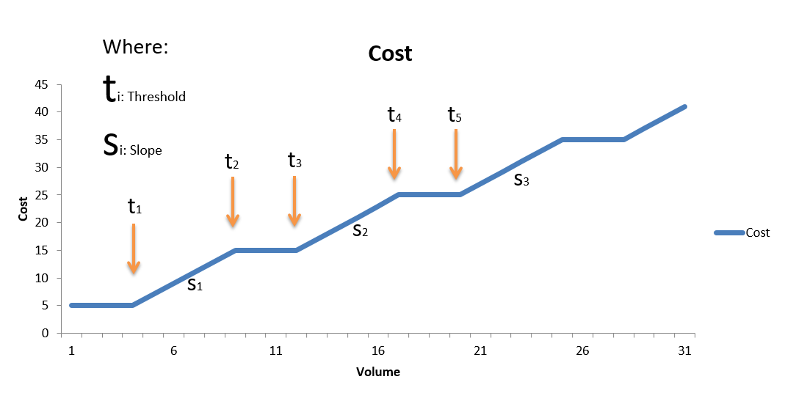

**Figure 1: $t_{1},t_{2},t_{3},t_{4},… t_{p}$ are thresholds between each price tier and $S_{1i},S_{2i},S_{3i},S_{4i},…S_{qi}$ are slopes between each price tier in average Line Haul Pricing from DCs to DAs.**

$$Min \sum_{i,j}{\left(C_{ij}+0.001*d_{ij}\right)*y_{ij}+ }\sum_{i}{*C_{i}*x_{i}+[\left(V_{i}-t_{1}\right)*S_{1}*d_{1i}-\left(V_{i}-t_{2}\right)*S_{1}*d_{2i}+\left(V_{i}-t_{3}\right)*S_{2}*d_{3i}-\left(V_{i}-t_{4}\right)*S_{2}*d_{4i}+\left(V_{i}-t_{5}\right)*S_{3}*d_{3i}]) }$$

$i:DA$

$j: customer zip code$

$C_{j}:cost of going from DA i to customer zip code j$

$d_{ij}:decisiion variable of assigning DA i to customer zip code j$

$$t_{1},t_{2},t_{3},t_{4}:thresholds between each price tier$$

$$S_{1i},S_{2i},S_{3i},S_{4i}:slopes between each price tier$$

$V_{i}:Volume of goods transport to DA i$ from Home Depot DCs

$$d_{1i},d_{2i},d_{3i}:decision variables of selecting price threshold 1,2,3 to DA i$$

$$x_{i}=\left\{\begin{aligned}1, &if DA i is open \\ 0, &Otherwise\end{aligned}\right.$$

$$\sum_{j}{y_{ij}≤x_{i}}*1000 for ∀i$$

$$d_{1i}=\left\{\begin{aligned}1, &if V_{i}>t_{1} \\ 0, &Otherwise\end{aligned}\right.d_{2i}=\left\{\begin{aligned}1, &if V_{i}>t_{1} \\ 0, &Otherwise\end{aligned}\right.d_{3i}=\left\{\begin{aligned}1, &if V_{i}>t_{1} \\ 0, &Otherwise\end{aligned}\right.d_{4i}=\left\{\begin{aligned}1, &if V_{i}>t_{1} \\ 0, &Otherwise\end{aligned}\right.$$

$$d_{1i}≤\frac{V_{i}}{t_{i}} for ∀j$$

$$\sum_{i}{y_{ij}=1 for ∀j }$$

*1000 is inserted as the large number M